IT Accessibility Review Procedure (P2P)
Definitions of terms
WCAG (Web Content Accessibility Guidelines): The international standards from the W3C for making digital content accessible to people with disabilities, structured around four core principles (POUR): Perceivable, Operable, Understandable, and Robust, with conformance levels A, AA, and AAA, and often mandated in regulations like the ADA for government websites. They provide actionable guidelines for developers, designers, and content creators to ensure websites and apps work for everyone, including users of assistive technologies like screen readers, and cover aspects like sufficient color contrast, keyboard navigation, and alt text. As a note, at the moment, SSU requires 2.1 AA standards be met; anything above that is not a requirement and does not need to be included in EEAAP’s and other documents. Other CSUs may differ in their requirements.

Voluntary Product Accessibility Template (VPAT): A template that companies can use to fill out whether their product supports, partially supports, or does not support various WCAG guidelines. Which, when filled out and joined with other info becomes an ACR. Though many requisitions will not include them, they can sometimes be found on the product's website, or by asking the requestor to contact the vendor.

Accessibility Conformance Report (ACR): A report that outlines how a product either meets or does not meet various WCAG standards. ACRs often also include a 508 report, which outlines which senses are needed to use the product. They are rarely referenced as ACRs, so you will see me call them VPAT’s quite often.

Equally Affective Alternative Access Plan (EEAAP): A plan set forth between IT and the department/requestor to create an alternate path for users with disabilities whether it means finding support for the users, creating alternate paths that don’t involve the product that would still allow them to complete the same task, or simply stating that they can’t be penalized for not using the product if they can’t because of their disabilities. There are various alternatives that can be used in EEAAPs and they are often decided on a case by case basis.

Temporary Alternative Access Plan (TAAP): Similar to EEAAP’s it is a formal agreement and review of the product created between the purchasing department, IT, and any other departments involved to set forth a temporary plan that accommodates users with disabilities while the vendor/product fixed the barriers to accessibility. This is an agreement only made for products with severe barriers where the product is required and no alternative can be used, or the barriers are actively being worked on. They require executive signatures and often meetings to agree upon accommodations that are feasible and equally effective as using the product.

Quick Links:
Google Drive VPAT/EEAAP & TAAP storage (SSU, access required)
CSU ATI Sharepoint (Access required)
SFBRN TAAP Repository (Access required)
Canned Language (Access required)
ATI Review Process,
- From the P2P home page, navigate to Orders > Approvals > Requisitions to Approve to access your list of pending requisitions.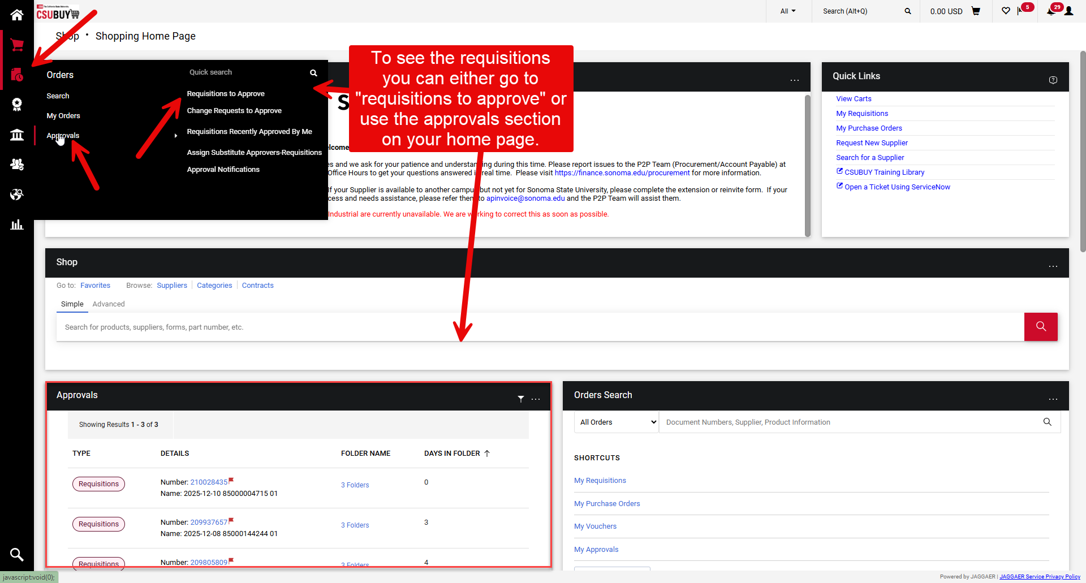
- Once you are viewing the list of pending requisitions, select the requisition number to open the requisition for review.
Note: Do not select the vendor name, as it will take you to the vendor information page, which is not part of the requisition review and approval process.
- Once the requisition is open, scroll past the General Information section to the Items section.
The Items section provides the details of the purchase, including:
- The product or service being purchased.
- The quantity of licenses or items requested.
- The department making the purchase.
- To view additional information about the purchase, such as the intended use case, user count, and other request details, select the IT Software Request button.
Note: Depending on how the requisition was submitted, the layout and format of the request form may vary.
  - Navigate to the General IT Software Information section of the form. This section typically includes:
- A link to the product's website.
- Whether the request is for a new purchase or a renewal.
- Whether the purchase is intended for system-wide use.
- Who will use the product (students, faculty, staff, and/or the public).
- The estimated number of users.
- A description of the intended use of the software.
- To begin actually reviewing the product, you will want to take note of the following items to gauge the impact of the product.
- Is a VPAT (Voluntary Product Accessibility Template) attached?
  - If a VPAT is not included, determine whether one is available from the vendor.
- Who will use the product, and how many users are affected?
  - Consider the estimated number of users and whether they are students, faculty, staff, or members of the public.
- How will the product be used?
  - Determine whether the product is required for employment, coursework, research, or other essential university functions. Products that are required for users to complete their work or academic responsibilities generally require a higher level of accessibility.
- Is the product itself an accessibility accommodation?
  - Examples include screen readers, note-taking software, translation tools, captioning software, or other assistive technologies. These products may require a different evaluation approach because their primary purpose is to improve accessibility.

- Check for existing TAAPs or EEAAPs in the CSU-Wide Repository, the SFBRN TAAP folder and the SSU EEAAP Google Drive. If the use case, quantity of users, etc are similar you can use the accommodation to guide your new TAAP should the product need one.
- Continue your review by examining the attached VPAT, if one is provided.
  - Review all WCAG 2.1 Level A and Level AA success criteria.
  - Note every criterion marked "Partially Supports" or "Does Not Support." These indicate potential accessibility issues that may require a TAAP, EEAAP, or additional review.
  - Ignore criteria outside the scope of WCAG 2.1 A/AA unless specifically requested.
  - If all applicable WCAG 2.1 A and AA criteria are marked "Supports," consider the VPAT a 10/10 VPAT with no identified accessibility concerns.
- If a VPAT is not attached to the requisition and cannot be found in the shared Google Drive, search the vendor's website. Many vendors publish VPATs or Accessibility Conformance Reports (ACRs) on their Accessibility, Compliance, or Legal pages. If you cannot locate one on their website, search using the product name followed by "VPAT" (e.g., Product Name VPAT), as this will often locate a publicly available document.
- If you are reviewing a requisition for Sonoma State University, also check the shared Google Drive folder titled "Approved Software VPAT" to determine whether the product has already been reviewed.
- If you are unable to locate a VPAT and the product will be used by more than one user, add a comment in P2P requesting that the requestor obtain a current VPAT from the vendor. If you were unable to determine the number of users or have additional questions about how the product will be used, include those questions in the same comment. Be sure to tag or select the requestor's name in the comment so they receive an email notifications

As a note, if the vendor does not have a VPAT available and the product has a medium to large quantity of users, is required for work or classes, etc, a TAAP will be needed for approval.
- “Hi ___,
Could you please request the product's Voluntary Product Accessibility Template (VPAT) from the vendor? A VPAT is a document in which the vendor describes how their product conforms to recognized accessibility standards (such as WCAG and Section 508). It helps us evaluate the product's accessibility features, identify potential barriers for users with disabilities, and determine whether additional testing or accommodations may be needed as part of our accessibility review.
Thank you,
________
- Determining Product Risk
A product is generally considered high risk if one or more of the following apply:
- It will be used by more than 25 users.
- It is required for employees, faculty, or students to perform their job duties or complete coursework.
- It is available to or used by the public.
- It supports a critical university business function or academic program.
High-risk products typically require a Technology Accessibility Assessment Plan (TAAP) before they can be approved.

A product is generally considered low risk if one or more of the following apply:
- It will be used by one person or a small group (25 or fewer users).
- Use of the product is optional and not required for work or coursework.
- The product is being purchased solely as an individual accommodation.
- The product has a current VPAT demonstrating strong accessibility with no significant accessibility barriers.
- The product presents minimal accessibility risk based on its intended use and audience.
Low-risk products typically do not require a TAAP and may be approved with the appropriate approval language documented in the P2P comments.
  - Use the template language below and add this to P2P as a comment, then to approve, press the red button in the top right corner that states “Approve/Complete & Show Next”. If you haven’t already assigned the requisition to yourself, you will first see “Assign & Further Actions”.
“This requisition has successfully passed the Accessibility Review. Note: This is a low-risk procurement with __ maximum users. This approval has been discussed with ________. If the requestor needs additional users, or if any users have trouble accessing the product, the requestor should contact the Accessibility Services Analyst for guidance.”
  - Note: Risk should always be evaluated holistically. User count is only one factor. Products that are required for instruction, essential job functions, or public-facing services may be considered as high risk even if the number of users is relatively small. Likewise, products with a larger user base may be considered lower risk if they demonstrate strong accessibility and present minimal barriers.

Anything that is between these criteria tends to be considered medium risk, and discretion. Previous decisions and guidance from supervisors are used to decide whether a TAAP is required or not.
- If additional information is required for your review, use the following templated language to ask, if there’s no templated language available for the question, be sure to write the question in a way that provides a plain language explanation of what information you need and why.

Accurate User Count

Hi,
Could you please provide the most accurate estimate of the number of users who will be using this product? This information helps us assess the accessibility review's impact and prioritize any identified accessibility issues.
Thank you!

- How to write a TAAP?
- If a Technology Accessibility Assessment Plan (TAAP) is required, use the TAAP template located in the SFBRN Shared TAAP folder in Box.
  - Make a copy of the template.
  - Rename the file using the following naming convention:
ProductName_Campus_Month Year
Example:
    - Asana_SSU_December 2026
    - Slate_CSUEB_March 2027
    - Zoom_SFSU_July 2026

- Include links to any available accessibility documentation in the TAAP whenever possible. This may include:
    - VPAT (Accessibility Conformance Report)
    - Accessibility Statement
    - Accessibility Roadmap
    - Accessibility webpage
    - Any additional accessibility documentation provided by the vendor
    - These resources should be referenced in the appropriate sections of the TAAP to support the accessibility assessment. List any items categorized as partially supported or not supported within your school's WCAG standards.
- If a VPAT is not available, indicate that the product's accessibility could not be fully evaluated due to the lack of accessibility documentation. For example:
  - “Accessibility is currently unknown. The vendor was unable to provide a VPAT or equivalent accessibility documentation. As a result, potential accessibility barriers could not be evaluated and may exist.”

- Completing the Temporary Alternative Access Plan
  - Next, complete the Temporary Alternative Access Plan section of the TAAP. This section is typically developed in collaboration with the department responsible for implementing and supporting the product, as they are best positioned to identify appropriate accommodations and alternative methods of access.
  - If a TAAP is required, add a comment in P2P informing the requestor that, based on the product's intended use, user population, accessibility documentation (or lack thereof), and overall risk, the purchase requires a Technology Accessibility Assessment Plan (TAAP).
  - Request that they identify the individual responsible for administering or supporting the product within their department and ask them to provide their availability for a brief meeting. You may use language similar to the following:
- “Based on our accessibility review, this purchase requires a Technology Accessibility Assessment Plan (TAAP). To complete the assessment, we would like to meet with the individual responsible for administering and supporting this product within your department to discuss its intended use and develop an appropriate Alternative Access Plan. Please provide their availability, and we will schedule a meeting.”
- During the meeting, work collaboratively with the department to:
- Confirm how the product will be used.
- Identify any known accessibility barriers.
- Develop appropriate alternative methods of access or accommodations for users who may encounter those barriers.
- Document any department-specific responsibilities for supporting accessibility.
Once the Alternative Access Plan and the Product-Specific Accessibility Statement have been completed and agreed upon, finalize the TAAP and route it through the appropriate approval and signature process. Included below is language to use for the TAAP process.
- “Thanks for providing the VPAT. Upon review, the vendor has indicated that there are several accessibility barriers in the product. If you want to move forward with this product, we will need to create a TAAP (Temporary Alternate Access Plan to document a plan for any students with disabilities who need to use the product. Please provide the availabilities for a person within your department who is responsible for enforcing the usage of this product or is able to provide support.”
- “Hi ___,
Thank you for sending over your availability, does (date and time) work for you? Once you've confirmed, I will send over a calendar invite.”
Lastly, download the document as a pdf, then upload it to Adobe Sign. In the message to the signer, place this text, filled in for the unique requisition.
- Hello All,
Attached is the Temporary Alternative Access Plan (TAAP) for the ______ product. Please review the entire document thoroughly and if you'd like to request any changes, please do not hesitate to reach out. Please be sure to place the product specific accessibility statement wherever it was agreed upon /marked in the agreement. This plan will need to be reviewed on or before 1 year from now if the product is planned to remain in use.
Best,
________

- Then place two signature boxes on the designated lines, then add the signature for the department chair/manager and the dean/division vice president, then add two “date signed” boxes next to each signature, ensuring that they are assigned to the correct person. Then send!
- Once the TAAP has been signed by all parties, download it, ensure its been placed in the google drive folder, the SFBRN TAAP folder and the CSU-wide SharePoint then approve the purchase.
- Sharepoint Access needs to be requested
- Lastly, how to approve various requisitions.
- For requisitions with an TAAP, once it's been signed, you will download a copy of the signed requisition and place it in the correct Google Drive folder for the requisition. Then, use the template language below and add this to P2P as a comment, then to approve, press the red button in the top right corner that states “Approve/Complete & Show Next”. If you haven’t already assigned the requisition to yourself, you will first see “Assign & Further Actions”:
“This requisition has successfully passed Accessibility Review. Note: This approval has been discussed with _____. If the requestor needs additional users, or if any users have trouble accessing the product, the requestor should contact the Accessibility Services Analyst for guidance.TAAP is active, signed copy on file. Should this product remain in use, this agreement will need to be reviewed on or before 1 year from this date.”

For low-risk requisitions, review step 10, line 2.

